Certificate of attendance

This certificate confirms that

Attended the afternoon session of
FMLM’s North of England Improvement Conference

2nd June 2014
Certified by
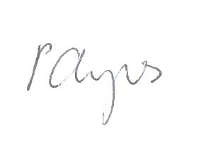

Phil Ayres
North of England Lead
Faculty of Medical Leadership and Management

This activity has been approved by the Federation of the Royal Colleges of Physicians
of the United Kingdom for 4 category 1 (external) CPD credits.

Event date: 2 June 2014 Issue date: 2 June 2014
CPD credits available for this activity: 4 points
