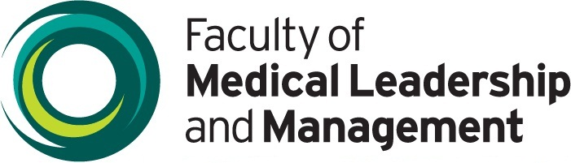

Certificate of attendance

This certificate confirms that

Attended the morning session of
FMLM’s North of England Improvement Conference

2nd June 2014
Certified by
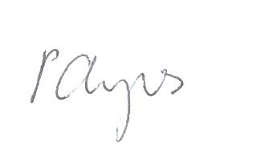

Phil Ayres
North of England Lead
Faculty of Medical Leadership and Management

Issue date: 2 June 2014

